**Supporting document for: Growing volunteers, growing community – please read along with PPT**

**Where are you planted? (slide #6)**

* Most of you present in the champions conference were connected to a church group or region.

**CTP (slide #9)**

**Scan me!**

* Most of you did not know that such resource existed.
* You can scan the QR Code or click: [www.adra.org.nz/CTP](http://www.adra.org.nz/CTP)

**What resources is available in this CTP link?**

* Application form, to apply for projects available in CTP.
* CTP Handbook – provides a narrative for your churches to thrive, the role of ADRA NZ and others, funding opportunities, project cycle and practical tools to guide you.
* We encourage that your church or committees read through this booklet – dedicate an hour each day to sit in your groups/committees, and go through each page to understand, plan, and map what your capacities are and how you want to serve – including utilising the services and funds available to you.

**Project Management Cycle (slide 10):**

* No one raised their hand, to say that they had seen the following cycle, in the CTP Handbook – which indicates that it is possible, that not all our members have looked and studied the CTP Handbook.
* If you want to serve well, and avoid burnout, and lack of volunteers – it is important that you as a group/committee, study and discuss this together.
* The details of each slice is inside the CTP manual – you also have Sally and your monthly meetings, to bring forth any questions or clarifications you may have.

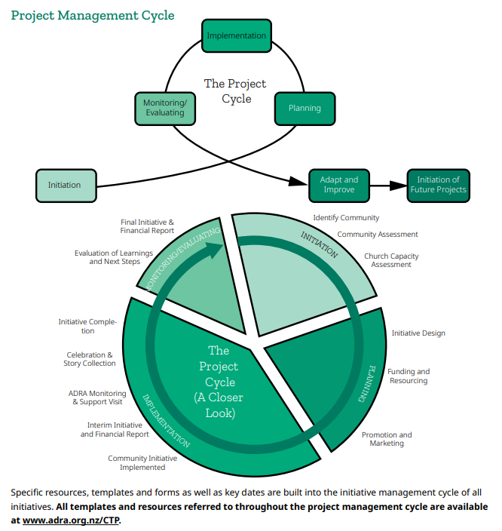

**Focus on Initiation**

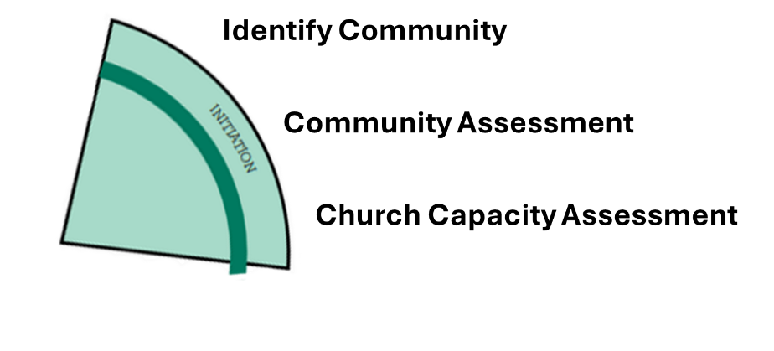

* IP focused its presentation on the first slice of the project management cycle – because from our experience, this is the most critical part of your planning that will dictate the future of your project success, or failure.
* So do this right – and take your time with it.
* Below, we have provided you with templates – to help guide your conversations, and your thinking and plans.

**Example worksheet based off the questions we went through together:**

Go through this worksheet, have a look at the examples together, what are your responses? What is your own context? This is a group activity, do it through Talanoa.

|  |  |
| --- | --- |
| **Identify Community** | *Example of how to answer these; but it must be part of your talanoa.* |
| **Part 1: Mapping Community** |  |
| 1. Who is already connected to you? | People in church (17 families).  A couple of neighbours who are non-church members (3 families).  The local health clinic.  The local AA (alcoholics anonymous)  The local Anger Management building |
| 1. Who do you feel called to serve, even if we’re not connected yet? | Within our church is ourselves – we are stressed, and tired, but passionate to serve.  Outside of our church – we would like to reach more people who could use a cup of soup and bread – the people that come through the AA and Anger Management is a good start. |
| 1. Who might be missing from your view? | Elderly people  Troubled youth.  In terms of our surrounding; we recognise that we are missing some important organisations in our area; example – the health clinic, the AA, there is also a rehabilitation clinic we are missing from our view/plan. |
| Part 2: |  |
| DISCOVER |  |
| 1. What barriers might be stopping us from reaching certain people? | We are not communicating to AA or AM who we are and services we can provide.  We do not really understand the people and cultural sensitivities in surveying households, to look for elderly people who may be feeling lonely, or grieving, etc.  We don’t have enough people to do the work. |
| 1. Who do we see every week but have never truly engaged? | There are a few elderly people we know and talk to; but we don’t really know much about them.  There is a family who always has a crying baby – they always leave early before we could talk to them. |
| 1. Whose stories haven’t we heard? | We haven’t heard the stories of the other organisations around our area – we have not talked to the health clinic, the AA, the rehab clinic etc. |
| CONNECT |  |
| 1. What barriers might be stopping us from reaching certain people? | Time and the fear/worry that they might expect something from us that we cannot help them with.  Having enough people to help. |
| 1. What would it take to build trust with them? | We have invited them many times to join our church events but they never come – maybe we need to try to go there; meet the people where they are, instead of expecting them to meet us where we are. |
| 1. Who do we need to learn from? | Would really like to connect with churches who do these kinds of community assessments well (maybe contact Sally or attend monthly meeting to put this question out there).  Would like to connect with organisations who needs us to be the hands and feet inside the community (again, contact Sally or attend monthly meeting to put out this question). |
| ALIGN |  |
| 1. What is our strength as a group? | We are passionate, but a few.  We are good listeners.  We are multi-cultural group.  We are consistent.  We are prayerful.  We are relational people. |
| 1. What breaks our hearts – and what are we equipped to respond to? | Many things:  People sitting alone at church.  Our youth turning to drugs.  Our kids going to school hungry.  Our elders being lonely, disregarded.  We are equipped to (we think, or have been doing):  Serving soup, bread and offer a prayer.  Opening our home to youth in trouble.  Going to visit our elders and having a cup of tea and a chat with them – checking up on them. |

**Important to Understand:**

* The foundation of your work starts from you as an individual, and a group.
* Check yourselves first; what capacities (skills, time, resources etc) do you have available to you, to allow you to serve the needs you have identified for your community.
* Are you (your church, or committee) the first project? – have a serious think about this question.
  + In identifying your weaknesses; you will be able to determine what trainings you and group will need to strengthen your foundation.
  + Apply for funding that could build your capacities and help you as a group to build your plans.
* **Do not be reactive with your plans to serve**:
  + We recommend you lay out a 3-year plan for your community.
  + Inside that plan – dedicate 3 months to yourselves to build your capacities; identify areas you require growth and build those.
  + Inside that plan – make a list of needs of your community (outside of your church) – you need to go out there, even if means picking up people to bring them to the site for a feed; or you are going to build household veggie gardens – project can buy the seeds, cuttings, etc then you take it there, and you help them build it.
  + Inside that plan – make a list of activities you can do, to serve your community.
  + Look around your community and identify who are the existing helpers that are out there – example; clinics, AAs, Rehabilitation Agents, etc – and have a meeting with those people to share with them what you do as a church, or as a committee.
  + Each year, you can look and obtain funding to action the activities you have in your 3-year plan for service. If additional funding is made available, you do not need to rush project design – you take from your 3 year plan and keep rolling that out.
* **Be proactive with your plans to serve:**
  + CTP for example, has funding that is released every few months – instead of rushing to write a proposal to apply for that funding, and be late in submitting – example; submit your proposal to Sally in your proposal, if a whole year of project

Sometimes – it helps to draw an actual map of your community. What is in your area? What services? What risks? What communities? This exercise helps you to think deeply about your surroundings and what you could be missing.

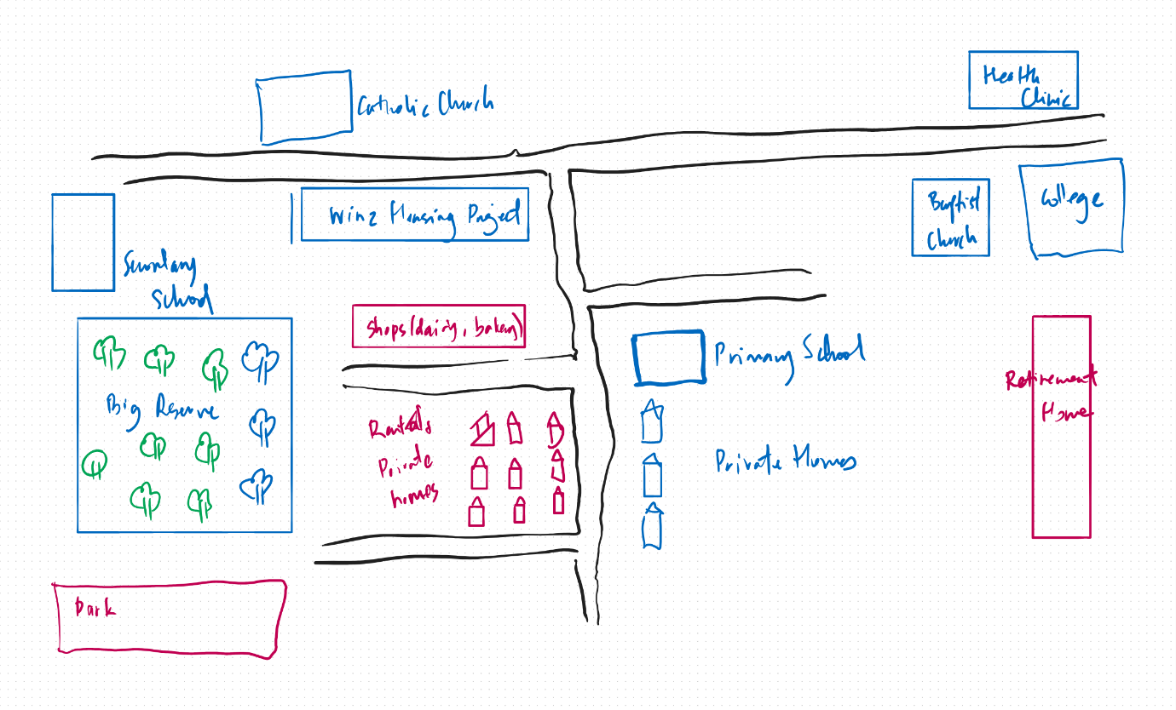

Repeat this exercise with the other two sections of Initiation – table the questions, discuss with your group/committee so you can visualise on paper how you look and how you are positioned.

**Blank worksheet for you to fill in**

|  |  |
| --- | --- |
| **IDENTIFY COMMUNITY** |  |
| **Part 1: Mapping Community** |  |
| 1. Who is already connected to you? |  |
| 1. Who do you feel called to serve, even if we’re not connected yet? |  |
| 1. Who might be missing from your view? |  |
| **Part 2:** |  |
| **Discover** |  |
| 1. What barriers might be stopping us from reaching certain people? |  |
| 1. Who do we see every week but have never truly engaged? |  |
| 1. Whose stories haven’t we heard? |  |
| **Connect** |  |
| 1. What barriers might be stopping us from reaching certain people? |  |
| 1. What would it take to build trust with them? |  |
| 1. Who do we need t learn from? |  |
| **Align** |  |
| 1. What is our strength as a group? |  |
| 1. What breaks our hearts – and what are we equipped to respond to? |  |

|  |  |
| --- | --- |
| **COMMUNITY ASSESSMENT** |  |
| **Part 1: Rapid Role Reflection** |  |
| 1. List what ways you are hearing from your community. |  |
| 1. Are you hearing from the same people all the time? |  |
| 1. Who do you think is missing? |  |
| **Part 2:** |  |
| **Needs and Challenges** |  |
| 1. What are the 3 top things people in your community are struggling with? |  |
| 1. What needs are unspoken or unseen? (e.g. mental health, loneliness, grief). |  |
| 1. What are the seasonal needs (e.g. winter, school holidays). |  |
| **Strengths and Resources** |  |
| 1. What are some strengths already in the community? |  |
| 1. Who are the people already helping quietly? |  |
| 1. What community traditions, practices or spaces are building belonging? |  |
| **Barriers and Trust** |  |
| 1. What might stop someone from asking for help? |  |
| 1. Are there trust issues? – with us, church, others? |  |
| 1. How do we make people feel safe, and not judged? |  |

|  |  |
| --- | --- |
| **CHURCH CAPACITY ASSESSMENT** |  |
| **Reflect Together on these 4 Capacity Areas** | |
| **Part 1: People and Time** |  |
| 1. Who in your church can volunteer (list them by name) |  |
| 1. What age groups are active? |  |
| 1. Are they stretched across many ministries? |  |
| 1. Do you have skilled volunteers? |  |
| 1. Are we realistic about how much time people have? |  |
| **Space and Facilities** |  |
| 1. What spaces can we use? (halls, etc) |  |
| 1. Are these accessible to communities? (location, hours) |  |
| 1. Do we have storage, toilets, safe gathering places? |  |
| **Finances and Materials** |  |
| 1. What funds are readily available? |  |
| 1. What giving patters do we have? |  |
| 1. Do we have access to materials/supplies (e.g. food, hygiene packs, beds, etc) |  |
| **Systems and Support** |  |
| 1. Do we have clear roles or are we always relying on the same people?   (list people, and roles) |  |
| 1. Do we have good communication channels? (WhatsApp, email etc) |  |
| 1. Do we get support from leadership, ADRA, Union/NZPUC, etc? – make a list of who is supporting you. |  |
| **Part 2:** |  |
| **Reflections and Discussions** |  |
| 1. What are you ready to do now? |  |
| 1. What would you like to do but need training for? |  |
| 1. What capacity gaps can be filled by others in your surrounding area (e.g. clinics, rehabs, AAs etc) and by others (e.g. churches, ADRA, NZPUC etc) |  |
| 1. Where are we saying yes? |  |
| 1. Where are we saying “not yet”? |  |

End