ALMOND FETA

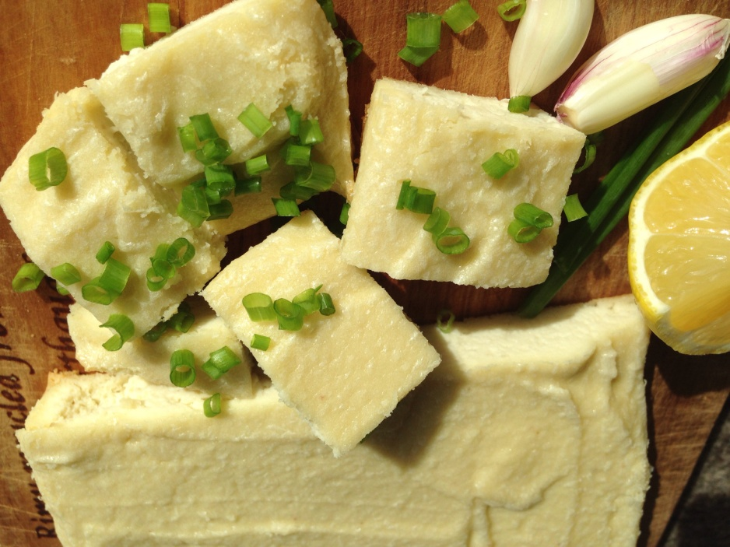

1 cup ground almonds
1/4 cup lemon juice
3 Tblspn olive oil
1 clove garlic
1 tsp salt
1/2 cup water

Place almonds with all other ingredients into Bullet and then absolutely blend to smithereens.

Spread mixture about 2cm deep over a sheet of baking paper on a baking tray.
Back at 140C for 30 mins

Remove from oven - it should be slightly yellowed on top.
Cool on rack, then slice into cubes.

This feta can be used in many different ways. It's nice in sandwiches with fresh bread, tomatoes and lettuce!

Store in fridge in an airtight container. Keeps for about 4 days.

